**Crowdfunding Data Analysis**

**Part I**

**1**.Data Conclusion:

1. Crowdfunding campaigns in theater are the most successful and the most ineffective.
2. In the US plays campaigns are the most successful
3. Overall, march is the month with most campaigns.

**2**. This data set won’t let us understand why some campaigns were cancelled, successful, or failed.

**3.** We could create a table showing the relationship between the percent founded and the campaigns’ outcome.

**Statistical Analysis**

**Part II**

|  |  |
| --- | --- |
| **Successful** | |
| **Mean** | 851.15 |
| **Median** | 201 |
| **Minimun # of backers** | 16 |
| **Maximun # backers** | 7295 |
| **Variance # of backers** | 1606217 |
| **Standar Deviation of # backers** | 1267.36601 |

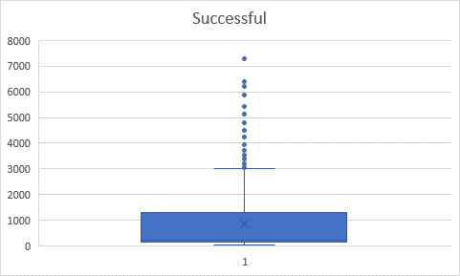

|  |  |
| --- | --- |
| **Failed** | |
| **Mean** | 585.6154 |
| **Median** | 114.5 |
| **Minimun # of backers** | 0 |
| **Maximun # backers** | 6080 |
| **Variance # of backers** | 924113.5 |
| **Standar Deviation of # backers** | 961.3082 |

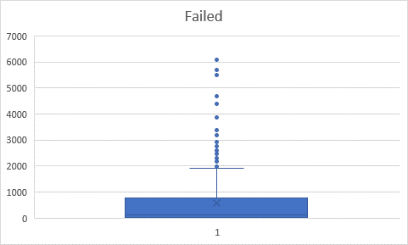

1. By looking at the distribution of the data, the median will be a better representation of the data. The extreme values on both data sets can affect the mean.
2. Looking at the data using the median, variance, and standard deviation. I can conclude that successful data has more variability.